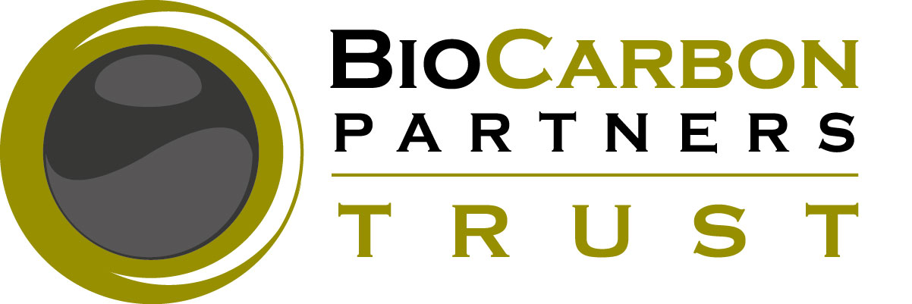
6, Tukuluho Rd., Longacres,
Post Net No. 481
Private Bag E891,
Lusaka

To: Community Leaders and Representatives
Project Zone, Lower Zambezi REDD+ Project
Chilimba, Mweeshangombe, Namanongo, Ndubulula Zones
Rufunsa District, Lusaka Province
Zambia
14 December 2013
Dear Sir or Madam,

RE: INTRODUCTION TO BCP COMMUNITY SENSITIZATION AND CONSULTATION PROGRAM

On behalf of BioCarbon Partners, it is my pleasure to provide you with this introduction to BCP’s Sensitization and Consultation Program, which has been improved for 2014.

BCP’s Community Sensitization and Consultation Program is led by BCP’s Sensitization Officer, Biston Nkhoma, and is supported by the Community Engagement Manager, Mr. Darlington Chipita, the Community Engagement Officer, Hildah Mbalazi, and the Community Mobilizers for each zone.

BCP’s Community Sensitization and Consultation Program is designed to improve awareness, understanding and support for BCP’s REDD+ activities taking place as part of the Lower Zambezi REDD+ Project. The most important aspects of BCP’s community work are effective community consultation and engagement. In order to do this, it is necessary for us to sensitize and consult with local community stakeholders, in line with the principles of obtaining Free, Prior and Informed Consent (FPIC) from our local community partners.

It is in this spirit of partnership and consultation that I kindly request that you invite and allow the members of BCP’s Community Engagement Team to bring BCP’s Community Sensitization Program to your respective zones and villages. This program is designed to provide regular and accurate information about BCP’s project activities, and to provide community stakeholders with an opportunity to ask questions and provide feedback.

BCP aims to hold “Sensitization and Consultation Meetings” in each village in every zone within the Project Zone for the Lower Zambezi REDD+ Project, which includes: Chilimba, Mweeshangombe, Namanongo and Ndubulula zones. We aim to build long-term partnerships, trust and understanding among community stakeholders. Each meeting is designed to:
- Provide accurate information about BCP’s REDD+ activities to community members
- Give community members an opportunity to ask questions and provide feedback about BCP’s REDD+ activities
We hope to “bring BCP to local communities,” by targeting households and villages for individualized sensitization and engagement opportunities. BCP aims to work with ALL community stakeholders, and to involve community stakeholders of all ages, ethnicities and political affiliations, irrespective of gender, socioeconomic status or language, in our projects. In the long term, we aim to sensitize, consult and engage with all community members living within the Project Zone for the Lower Zambezi REDD+ Project.

I hope that you will welcome this opportunity to begin an effective sensitization, consultation and engagement process in partnership with the representatives of our Community Engagement Team. Please let us know if you have any questions or concerns.

Sincerely,

